

**Van Rental Management System**

In Partial Fulfilment of the Requirements for the course

CC14 - Database Systems and Information Management

by

Arbie Delizo

Maria Liza Paano

Submitted to:

Engr. Florence B. Reyes

October 14, 2019

**TABLE OF CONTENTS**

EXECUTIVE SUMMARY 1

SYSTEM SELECTION AND DEFINITION 2

**Case Description** 2

**General Description** 2

**Basic Operation** 2

**Information Needs** 2

**Employee/Admin Registration** 3

**Reservation Date** 3

**Booking** 3

**Van’s Availability** 3

**Maintenance Report** 3

**Repair Report** 3

**Driver’s Information** 3

conceptual database design 4

**van rental management system** 4

**conceptual data model** 5

**logical data model** 6

**data dictionary model** **7.**

PHYSICAL DATABASE DESIGN 8

**logical database design** 9

**physical database design** 10

**sample erd (workbench)** 15

**sample table (workbench)** 16

feedback, conclusion and recomendation 22

reference 23

Appendices 24

Appendix 1: DATABASE DOCUMENTATION 24

Appendix 2: CURRICULUM VITAE 24

**EXECUTIVE SUMMARY**

The Van Rental Management System aims to address the problem of our client in their business which is booking and we added other features that does not only address their booking problem but also manages their vehicles and keeps track of there their van’s maintenance and repair. The system also addresses there booking problem, and we also added a reservation feature in our system it can also add new employee and driver.

Some features of our system also include adding, deleting, and updating. This also tracts the maintenance and repair of the vans, this also includes the booking and reservation of the customer. The system solved the problem of our client which is to book and reserve vans for the customers.

**SYSTEM SELECTION AND DEFINITION**

**1 Case Description: Van Rental Management System**

**1.1 General Description**

The van rental is a growing business that provides services to people within the city. This agency has one branch and it’s trying to expand its business. It has 10 fleet vans registered within the city.

**1.2 Basic Operation**

The customers may call to reserve in advance or it can be a walk in transaction, and if it’s a last minute transaction the employee will look into the system if there are any available vans and if there is, arrangement could be done. Transaction could be a reservation or booking, transaction has a transaction number and transaction type.

In order for the system to function the employee needs to register to the system. The employee has first, middle and last name, email, birthdate, employee id, username, password, phone number, gender, address and position. The employee manages the transactions of the customer which includes the booking or the reservation. In order for the customer to complete his/her booking they first need to give their information, such as the customer id, customer’s name (first, middle and last name), address, email, phone number, gender and birthdate.

The booking includes the number of passenger, start date, end date and insurance plan while in reservation there is a reservation number and reservation date and status whether the customer wanted to proceed to booking or they wanted to cancel the reservation. The van has type, model, registration number, vehicle code and insurance. The van needs to undergo maintenance once a month, maintenance has maintenance date, maintenance code, address maintenance type, maintenance date and cost. If there are any complications or malfunctions, the van undergoes repair, in the repair there is a repair number, repair type, cost and repair date. The in the booking of the vehicle there is also a driver, the driver has driver id, driver’s name (first, middle and last name), insurance, phone number, email, birthdate, guardian name, and guardian phone number.

The maintenance, the repair has payment and the transaction receives payment from the customer the payment then is receive by the employee, payment has the payment type and payment number.

**1.3 Information Needs**

All data relating to vans, employee, maintenance, booking, driver, reservation, transactions, customer, payment and repair are to be stored in the database. The employee then puts all the credentials of the customer that made the reservation and how many people are going to use the van. The type of van is a 12 sitter van which means that the allowable people inside the van are 13 people including the driver.

* + 1. **Employee/Admin Registration:** First Name, Middle Name, Last Name, email, username, Password, Birthdate Phone Number.

This is the first step in adding another employee and also the username and password is important to ensure that the employee is registered in the system.

* + 1. **Reservation Date:** Reservation#, Reservation Date, Customer name, Customers Phone Number.

If the customer is not sure, he or she could reserve a van before booking, the employee then gives the customer a few days to confirm the reservation to make it an official booking.

* + 1. **Booking** Customer Name, Customer Address, Customers Phone Number, Insurance Plan, Estimated Length of Rental (start and end), Rate Period, Van type, Number of Passenger/s.

If the customer already did the reservation they will be asked about their personal information such as their name, address and phone number, email and birthdate. The insurance plan is based on the choice of the customer. The van type is the information need for the booking of the van. The length of rental is based on how long thus the customer wanted to rent the van it could be a couple of days, weeks or months, the rate period on the other hand is the actual amount the customer needs to pay.

* + 1. **Van’s Availability:** Type, Model, Van’s Registration#, Vehicle code, insurance.

Date today identify if the van is available or not. The vans are all licensed in a single state, so the van’s registration number can uniquely identify them. The vehicle code will also uniquely identify the van for the employee to ensure the availability also.

* + 1. **Maintenance Report:** Vehicle code, Maintenance date, Maintenance Type, Cost, Garage Name, Garage Address.
    2. **Repair Report:** Repair #, Vehicle code, Date of repair, Repair Name, Cost, Final Cost.

This report details are the fixes done on a solitary vehicle.

.

* + 1. **Driver’s Information:** First Name, Middle Name, Last Name, email, Phone Number, Birthdate, Guardian Name, Guardian Number.

This is to ensure that the driver is added in the system.

**CONCEPTUAL DATABASE DESIGN**

**Van Rental Management System**

The Van Rental Management System keeps track of the vehicles, the customers, the employee, payment, transactions, booking, reservation, maintenance, repair and the driver.

The employee is the one who has access to all the vans, transactions of the customer down to maintenance and repairs of the vans. The employee needs to login to the system where the s/he needs to input his/her username and password.

The van has a registration number, van code, model, type, and insurance. The van also needs to undergo monthly maintenance to check the engine and if there are any complications which needs repair, the repair has a repair number, repair type, cost, final cost and date. Maintenance has garage code, address, procedure name and date of procedure.

The customer on the other hand, books to the employee, the employee then, checks if there are any available vans on the date that the customer chooses. When the customers want to book a van the employee needs to have the information of the customer such as the id, name, email, address, phone number and the birthdate. The booking also includes the reservation date, Insurance Plan, Estimated Length of Rental (start and end), Rate Period, and van type.

The employee stores each drivers name, driver’s code, email, birthdate, phone number and address. A driver is assigned to one designated van and can work whenever there are any reservations but they need to report to the office.

**CONCEPTUAL DATA MODEL**

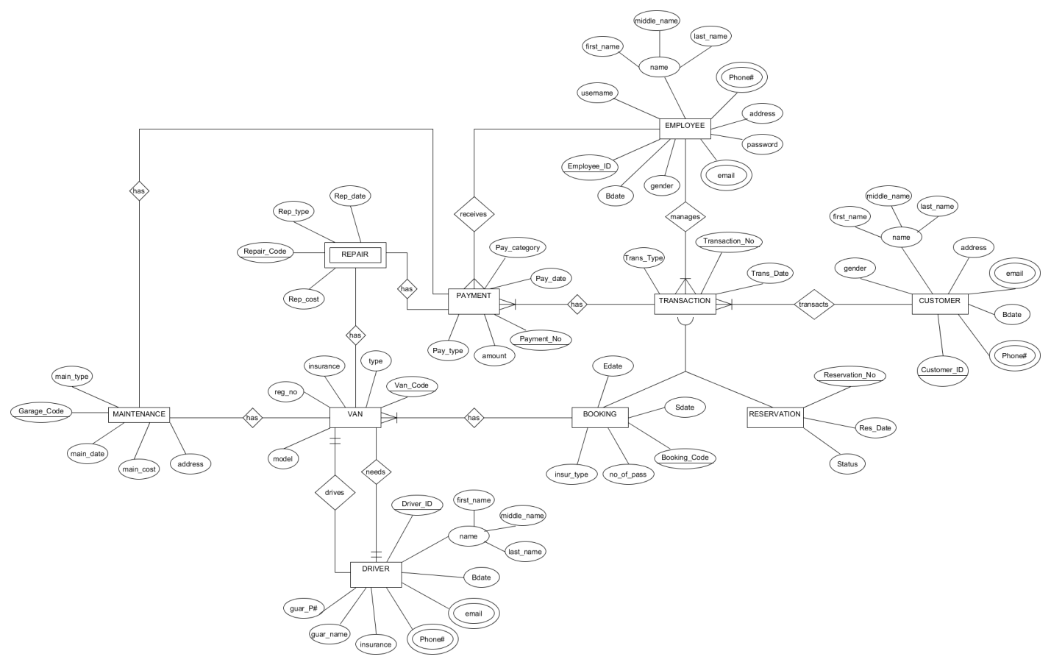

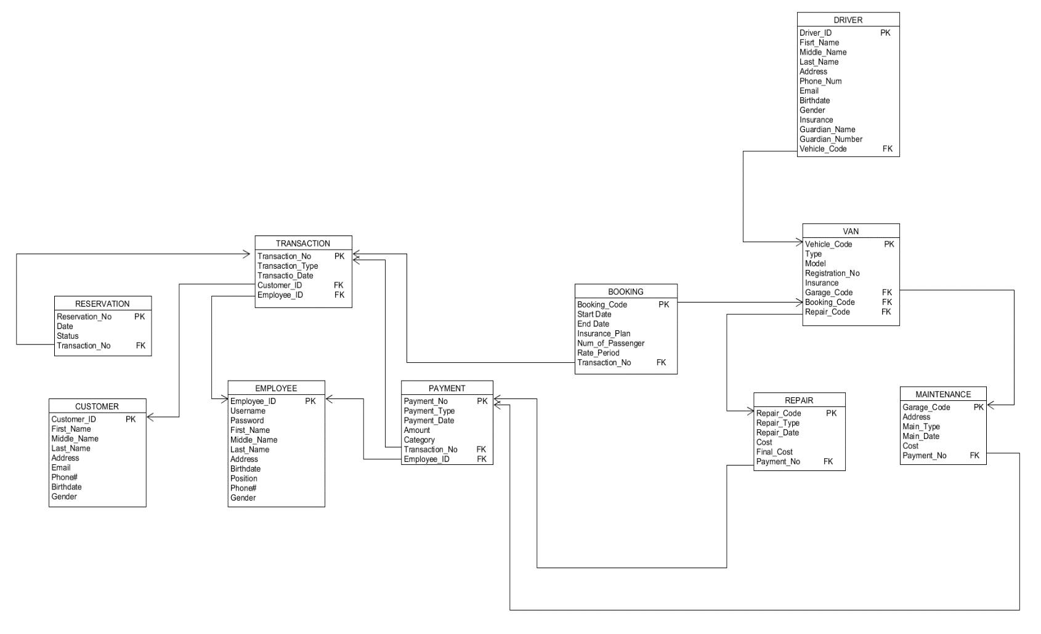**LOGICAL DATA MODEL**

**DATA DICTIONARY MODEL**

|  |  |  |  |  |  |  |  |
| --- | --- | --- | --- | --- | --- | --- | --- |
| **TABLE NAME** | **ATTRIBUTE NAME** | **CONTENTS** | **TYPE** | **FORMAT** | **REQUIRED** | **PK OR FK** | **FK REFERENCED TABLE** |
| **EMPLOYEE** | Emp_ID Emp _Lname Emp _Fname Emp _Mname  Birthdate Address email Phone_Num  Position  Gender  Username  Password | Employee’s Identity Employee’s Last Name Employee’s First Name Employee’s Middle Name Birthdate  Address Email Address Phone Number  Position  Gender  Username  Password | INT(11) VCHAR(45) VCHAR(45) VCHAR(45) DATE VCHAR(45) VCHAR(45) CHAR(11)  VCHAR(45) VCHAR(45) VCHAR(45) VCHAR(45) | 9999999999 Xxxxxxxxx Xxxxxxxxx Xxxxxxxxx dd-mm-yy Xxxxxxxxx Xxxxxxxxx 099999999 Xxxxxxxxx Xxxxxxxxx Xxxxxxxxx  Xxxxxxxxx | Y Y Y Y Y Y Y Y  Y  Y  Y  Y | PK |  |
| **CUSTOMER** | Customer_ID Cus_Lname Cus_Fname Cus_Mname  Birthdate Address email Phone_Num  Gender | Customer Identity Customer’s Last Name Customer’s First Name Customer’s Middle Name Birthdate Address Email Address Phone Number  Gender | INT(11) VCHAR(45) VCHAR(45) VCHAR(45) VCHAR(45) VCHAR(45) VCHAR(45) CHAR(11)  VCHAR(45) | 9999999999 Xxxxxxxxx Xxxxxxxxx Xxxxxxxxx dd-mm-yy Xxxxxxxxx Xxxxxxxxx 099999999  Xxxxxxxxx | Y Y Y Y Y Y Y Y  Y | PK |  |
| **DRIVER** | Driver_ID Driv_Lname Driv_Fname Driv_Mname  Birthdate Address email Phone_Num  Guardian_Name  Guardian_Number  Insurance  Gender  Van_Code | Driver’s Identity Driver’s Last Name Driver’s First Name Driver’s Middle Name Birthdate Address Email Address Phone Number  Guardian Name  Guardian Number  Driver’s Insurance  Gender  Van Code | INT(11) VCHAR(45) VCHAR(45) VCHAR(45) VCHAR(45) VCHAR(45) VCHAR(45) CHAR(11)  VCHAR(45)  CHAR(11)  VCHAR(45) VCHAR(45)  CHAR(11) | 9999999999 Xxxxxxxxx Xxxxxxxxx Xxxxxxxxx dd-mm-yy Xxxxxxxxx Xxxxxxxxx 099999999  Xxxxxxxxx 099999999  Xxxxxxxxx Xxxxxxxx  99999 | Y Y Y Y Y Y Y Y  Y  Y  Y  Y | PK  FK | VAN |
| **TRANSACTION** | Trans_No Trans_Type  Pay_No  Customer_ID  Emp_ID | Transaction Number Transaction Type Payment Number  Customer Identity Employee’s Identity | INT(11) VCHAR(45)  NT(11)  INT(11)  INT(11) | 99999  Xxxxxxxxx  99999  99999  9999999999 | Y  Y | PK  FK  FK  FK | PAYMENT  CUSTOMER  EMPLOYEE |
| **PAYMENT** | Pay_No  Pay_Type  Trans_No  Emp_ID | Payment Number  Payment Type  Transaction Number  Employee’s Identity | NT(11) VCHAR(45)  INT(11)  INT(11) | 9999999999 Xxxxxxxxx  99999  99999 | Y  Y | PK | TRANSACTION  EMPLOYEE |
| **BOOKING** | Booking_Code  Start_date End_date Insur_Plan Num_of_Pass  Van_Code | Booking Code Start Date End Date Insurance Plan Number of Passenger  Van Code | CHAR(5) DATE DATE VCHAR(45) INT(12)  INT(11) | 99999 dd-mm-yy dd-mm-yy Xxxxxxxxx 99999999  99999999 | Y  Y  Y  Y  Y | PK  FK | VAN |
| **RESERVATION** | Res_No  Res_Type  Status  Trans_No | Reservation Number Reservation Type  Status  Transaction Number | CHAR(5)  VCHAR(45)  VCHAR(45)  INT(5) | 99999  Xxxxxxxxx  Xxxxxxxxx  99999 | Y  Y  Y | PK  FK | TRANSACTION |
| **VAN** | Van_Code Reg_Num Van_Type Garage _Code Driver_ID  Rep_No | Van Code Registration’s Number Van Type Garage Code Driver’s Identity  Repair Number | CHAR(5) CHAR(7) VCHAR(45) CHAR(5) INT(11)  INT(11) | 99999 9999999 Xxxxxxxxx 99999 9999999999  9999999999 | Y Y | PK   FK FK  FK | MAINTENANCE DRIVER  REPAIR |
| **MAINTENANCE** | Garage_Code Address Pro_Name Date_of_Pro  Cost  Pay_No | Garage Code Address Procedure Name Date of Procedure  Cost  Payment Number | CHAR(5) VCHAR(45) VCHAR(45) DATE  INT(45)  DOUBLE(10,2) | 99999 Xxxxxxxxx Xxxxxxxxx dd-mm-yy  9999999999  9999999 | Y Y  Y  Y  Y  Y | PK  FK | PAYMENT |
| **REPAIR** | Rep_No Rep_Type Cost  Pay_No | Repair Number  Repair Type  Repair Cost  Payment Number | INT(11) VCHAR(45)  INT(50)  INT(50) | 9999999999 Xxxxxxxxx  9999999999  9999999999 | Y  Y  Y  Y | PK  FK | PAYMENT |

**PHYSICAL DATABASE DESIGN**

**Logical Database Design**

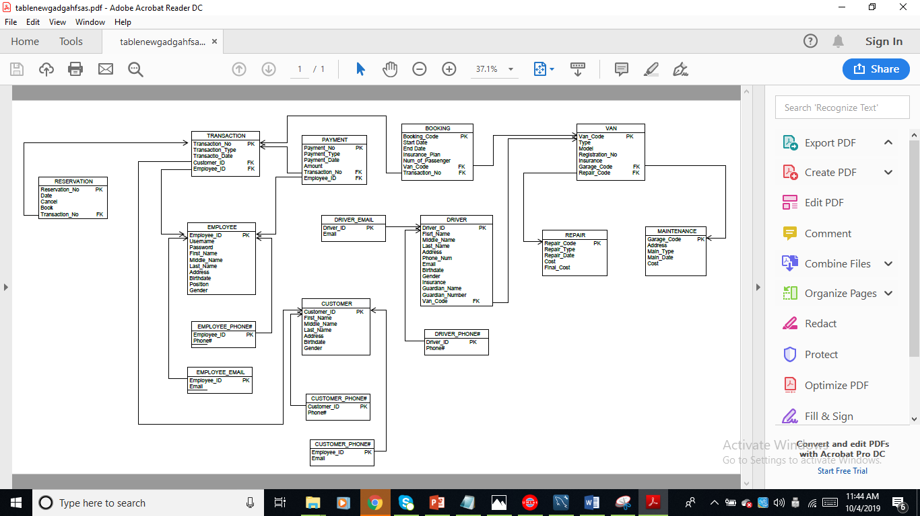

**Physical Database Design**

CREATE TABLE `booking` (

`Booking_ID` int(11) NOT NULL,

`BookDstart` date NOT NULL,

`BookDend` date NOT NULL,

`BookInsurance` varchar(45) NOT NULL,

`BookNumPass` int(11) NOT NULL,

`Transaction_No` int(11) DEFAULT NULL,

`Van_Code` int(11) DEFAULT NULL,

PRIMARY KEY (`Booking_ID`),

KEY `Transaction_No_idx` (`Transaction_No`),

KEY `Vehicle_Code_idx` (`Van_Code`),

CONSTRAINT `Transaction_No2` FOREIGN KEY (`Transaction_No`) REFERENCES `transaction` (`Transaction_No`),

CONSTRAINT `Van_Code2` FOREIGN KEY (`Van_Code`) REFERENCES `van` (`Van_Code`));

CREATE TABLE `customer` (

`Customer_ID` int(11) NOT NULL,

`Customer_FName` varchar(45) DEFAULT NULL,

`Customer_MName` varchar(45) DEFAULT NULL,

`Customer_LName` varchar(45) DEFAULT NULL,

`Customer_Address` varchar(45) DEFAULT NULL,

`Customer_Email` varchar(45) DEFAULT NULL,

`Customer_PhoneNumber` int(11) DEFAULT NULL,

`Customer_Birthdate` date DEFAULT NULL,

`Customer_Gender` varchar(45) DEFAULT NULL,

PRIMARY KEY (`Customer_ID`));

CREATE TABLE `driver` (

`Driver_ID` int(11) NOT NULL,

`DriverFname` varchar(45) DEFAULT NULL,

`DriverMname` varchar(45) DEFAULT NULL,

`DriverLname` varchar(45) DEFAULT NULL,

`Address` varchar(45) DEFAULT NULL,

`DrivePhoneNum` int(11) DEFAULT NULL,

`DriverEmail` varchar(45) DEFAULT NULL,

`Driver_Bdate` date DEFAULT NULL,

`Insurance` varchar(45) DEFAULT NULL,

`Guardian_name` varchar(45) DEFAULT NULL,

`Guardian_Pnum` int(11) DEFAULT NULL,

`Van_Code` int(11) DEFAULT NULL,

PRIMARY KEY (`Driver_ID`),

KEY `Van_Code_idx` (`Van_Code`),

CONSTRAINT `Van_Code` FOREIGN KEY (`Van_Code`) REFERENCES `van` (`Van_Code`));

CREATE TABLE `employee` (

`Employee_ID` int(11) NOT NULL,

`Employee_FName` varchar(45) DEFAULT NULL,

`Employee_MName` varchar(45) DEFAULT NULL,

`Employee_LName` varchar(45) DEFAULT NULL,

`Employee_Gender` varchar(45) DEFAULT NULL,

`Employee_Position` varchar(45) DEFAULT NULL,

`Employee_Birthdate` date DEFAULT NULL,

`Employee_PhoneNum` int(11) DEFAULT NULL,

`Employee_Email` varchar(45) DEFAULT NULL,

`Employee_Password` varchar(45) DEFAULT NULL,

`Employee_Address` varchar(45) DEFAULT NULL,

`Employee_Username` varchar(45) DEFAULT NULL,

PRIMARY KEY (`Employee_ID`));

CREATE TABLE `maintenance` (

`Garage_Code` int(11) NOT NULL,

`Main_Type` varchar(45) DEFAULT NULL,

`Address` varchar(45) DEFAULT NULL,

`Main_Date` date DEFAULT NULL,

`Cost` int(11) DEFAULT NULL,

PRIMARY KEY (`Garage_Code`));

CREATE TABLE `payment` (

`Payment_No` int(11) NOT NULL,

`Payment_Type` varchar(45) DEFAULT NULL,

`Transaction_No` int(11) DEFAULT NULL,

`Employee_ID` int(11) DEFAULT NULL,

`Payment_Date` date DEFAULT NULL,

`Amount` double DEFAULT NULL,

PRIMARY KEY (`Payment_No`),

KEY `Transaction_No_idx` (`Transaction_No`),

KEY `Employee_ID_idx` (`Employee_ID`),

CONSTRAINT `Employee_ID1` FOREIGN KEY (`Employee_ID`) REFERENCES `employee` (`Employee_ID`),

CONSTRAINT `Transaction_No` FOREIGN KEY (`Transaction_No`) REFERENCES `transaction` (`Transaction_No`));

CREATE TABLE `repair` (

`Repair_Code` int(11) NOT NULL,

`Repair_Type` varchar(45) DEFAULT NULL,

`Rep_Date` date DEFAULT NULL,

`Rep_Cost` int(11) DEFAULT NULL,

`Rep_TotCost` int(11) DEFAULT NULL,

PRIMARY KEY (`Repair_Code`));

CREATE TABLE `reservation` (

`Reservation_ID` int(11) NOT NULL,

`ResDate` date DEFAULT NULL,

`Cancel` varchar(45) DEFAULT NULL,

`Book` varchar(45) DEFAULT NULL,

`Van_Code` int(11) DEFAULT NULL,

PRIMARY KEY (`Reservation_ID`),

KEY `Van_Code_idx` (`Van_Code`),

CONSTRAINT `Van_Code3` FOREIGN KEY (`Van_Code`) REFERENCES `van` (`Van_Code`));

CREATE TABLE `transaction` (

`Transaction_No` int(11) NOT NULL,

`Transaction_Type` varchar(45) DEFAULT NULL,

`Transaction_Date` date DEFAULT NULL,

`Employee_ID` int(11) DEFAULT NULL,

`Customer_ID` int(11) DEFAULT NULL,

PRIMARY KEY (`Transaction_No`),

KEY `Customer_ID_idx` (`Customer_ID`),

KEY `Employee_ID_idx` (`Employee_ID`),

CONSTRAINT `Customer_ID` FOREIGN KEY (`Customer_ID`) REFERENCES `customer` (`Customer_ID`),

CONSTRAINT `Employee_ID` FOREIGN KEY (`Employee_ID`) REFERENCES `employee` (`Employee_ID`));

CREATE TABLE `van` (

`Van_Code` int(11) NOT NULL,

`Van_Type` varchar(45) DEFAULT NULL,

`Regis_No` varchar(45) DEFAULT NULL,

`Van_Insurance` varchar(45) DEFAULT NULL,

`Van_Model` varchar(45) DEFAULT NULL,

`Garage_Code` int(11) DEFAULT NULL,

`Repair_Code` int(11) DEFAULT NULL,

PRIMARY KEY (`Van_Code`),

KEY `Garage_Code_idx` (`Garage_Code`),

KEY `Repair_Code_idx` (`Repair_Code`),

CONSTRAINT `Garage_Code` FOREIGN KEY (`Garage_Code`) REFERENCES `maintenance` (`Garage_Code`),

CONSTRAINT `Repair_Code` FOREIGN KEY (`Repair_Code`) REFERENCES `repair` (`Repair_Code`))

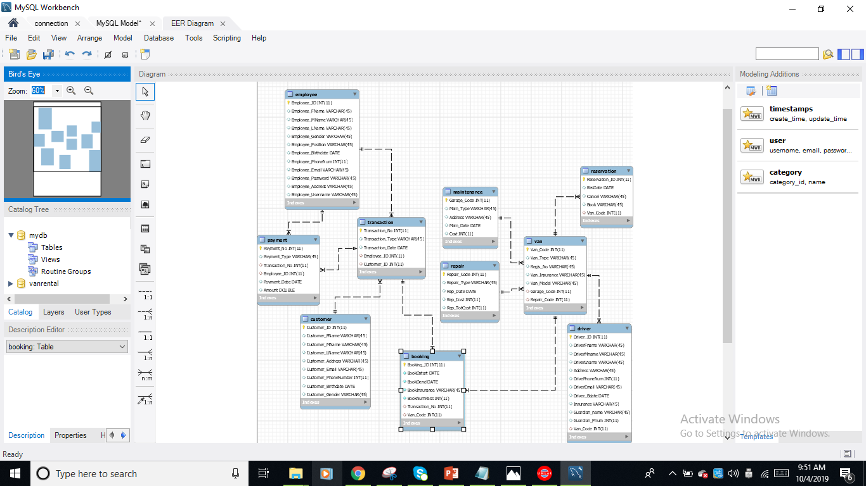**Sample ERD (Workbench)**

**Sample Table (Workbench)**

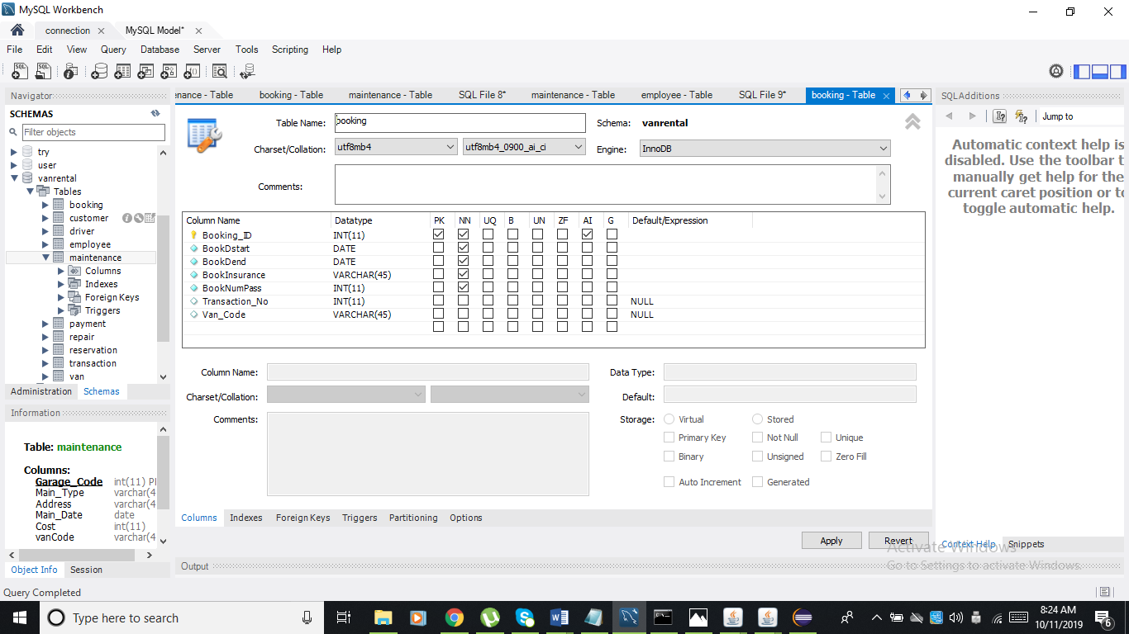

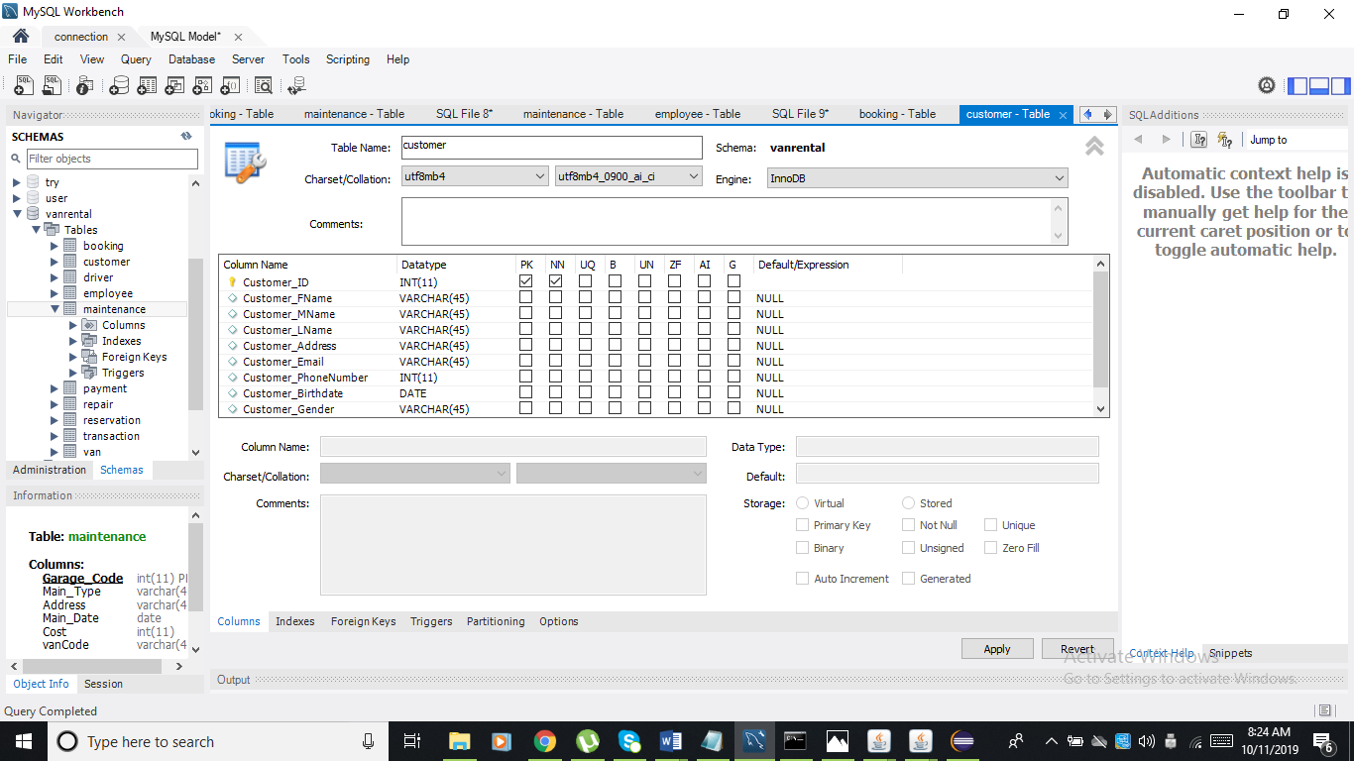

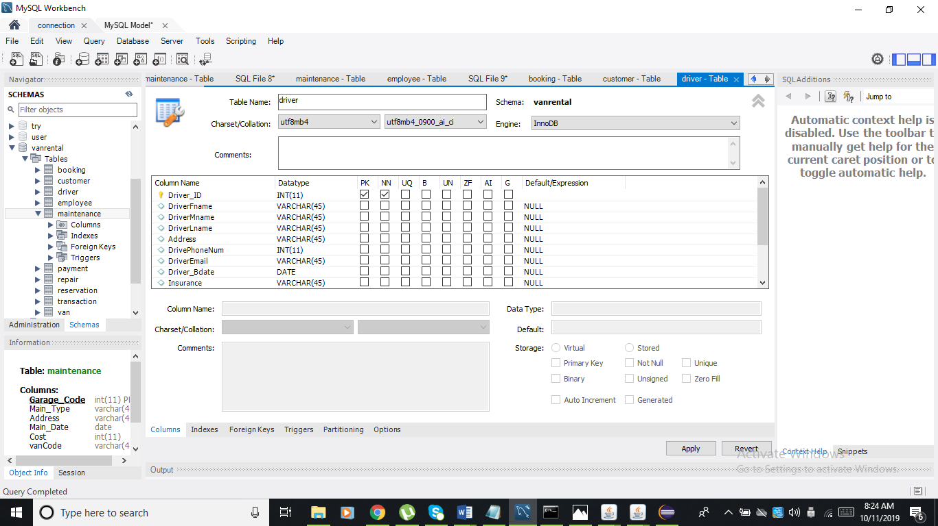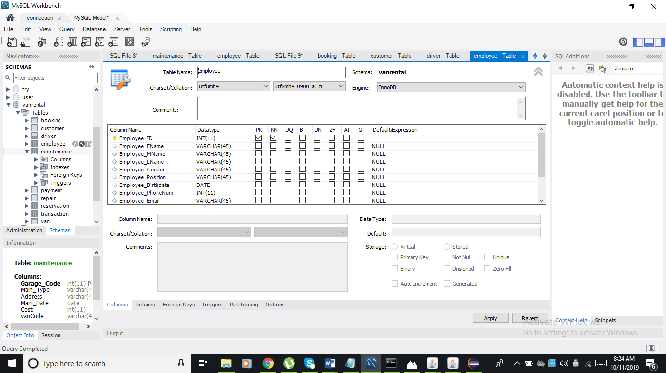

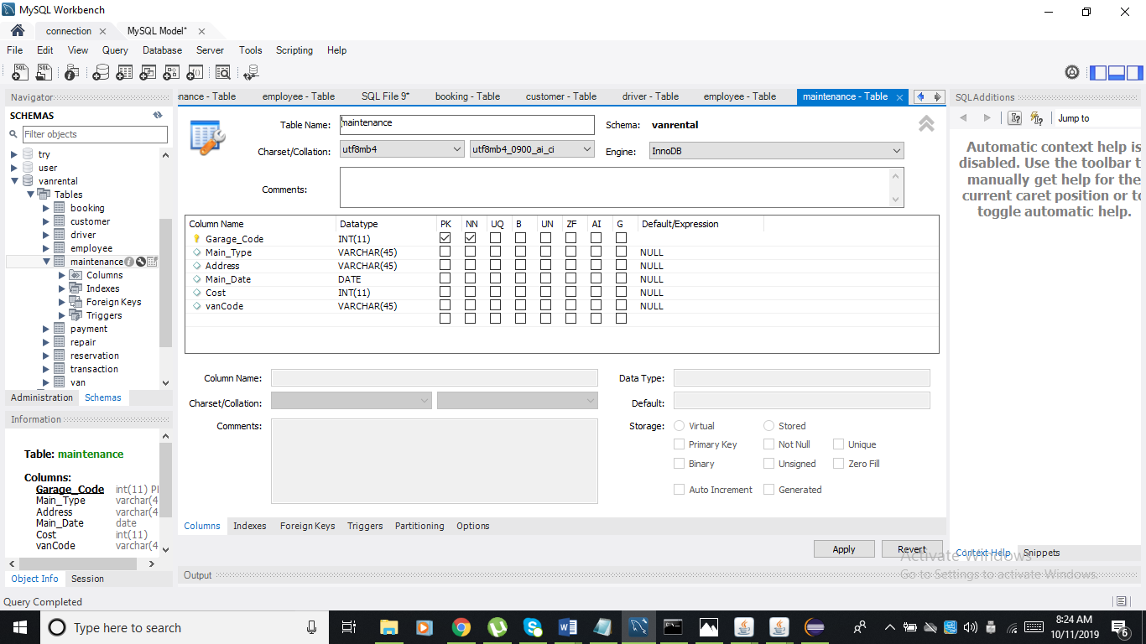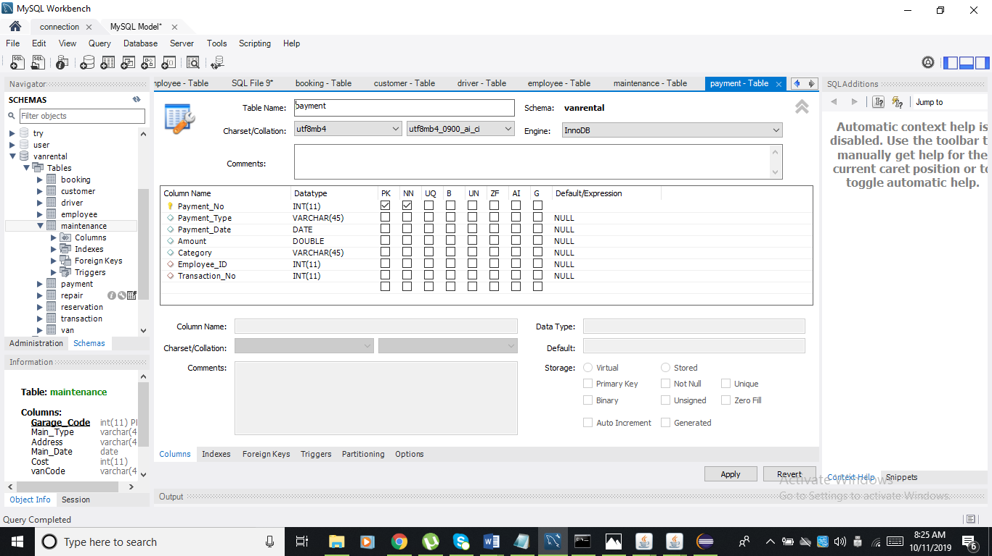

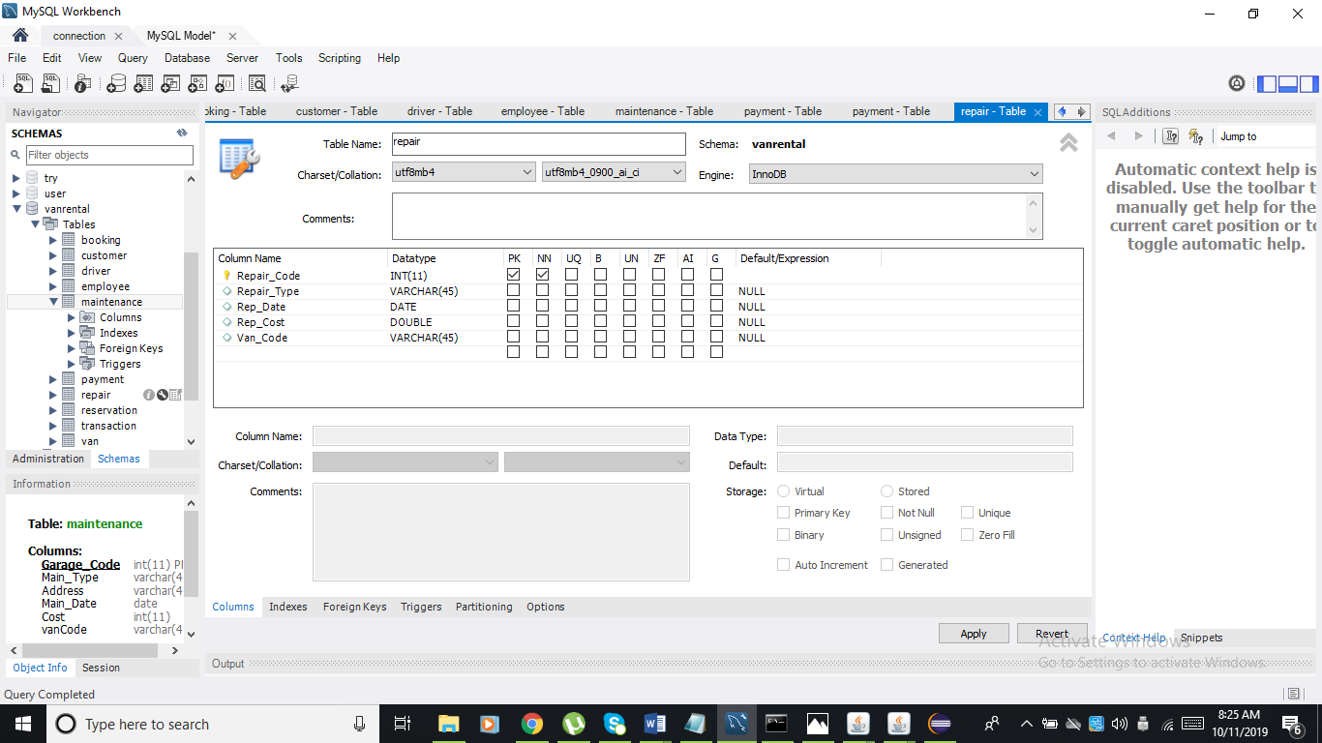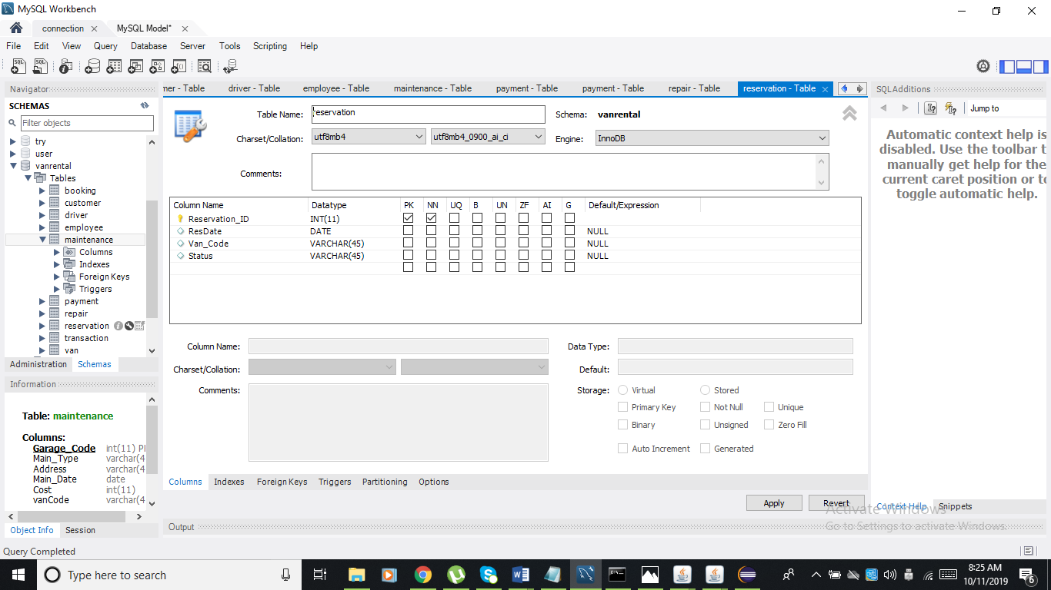

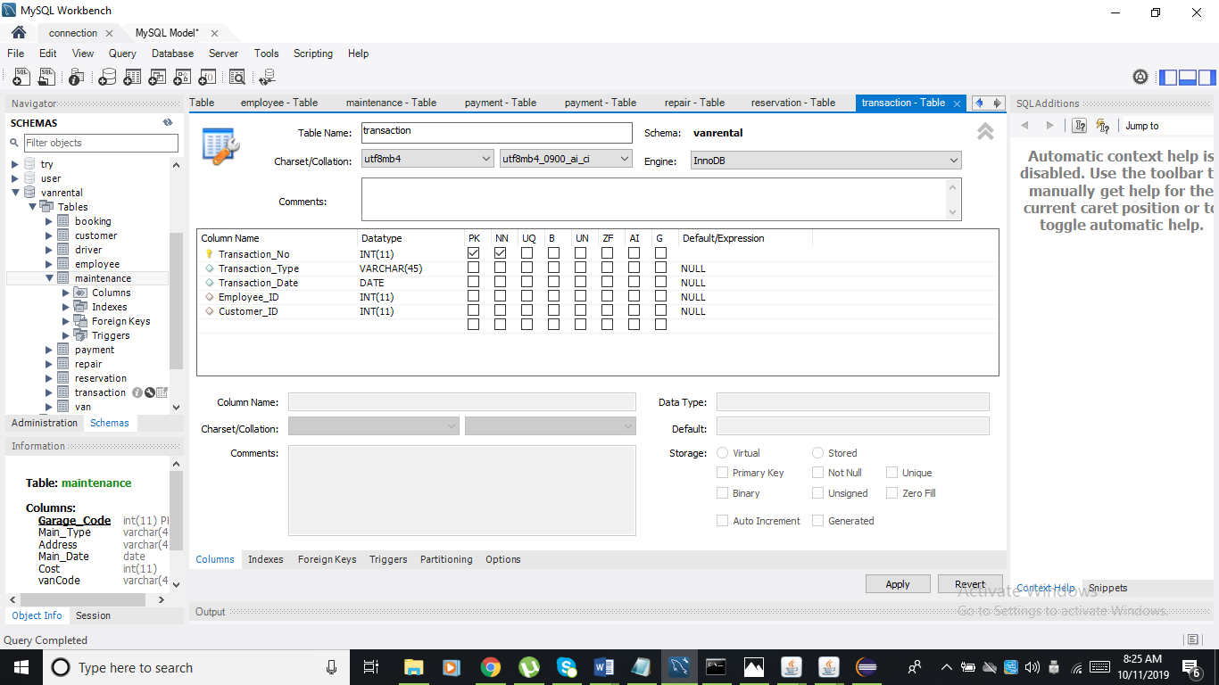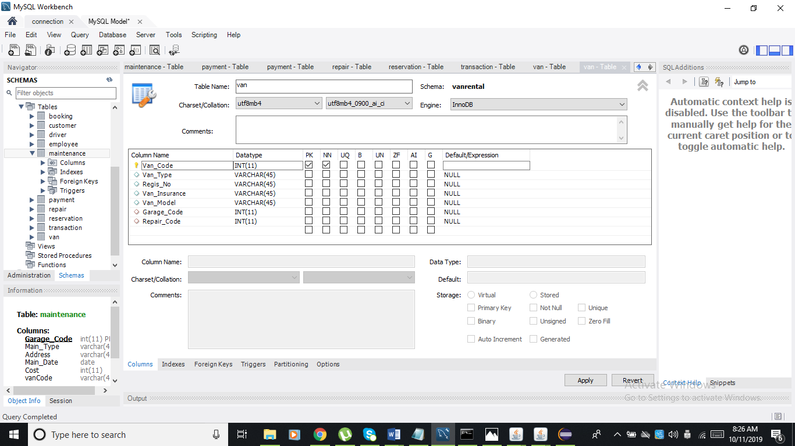

**FEEDBACK, CONCLUSION AND RECOMMENDATION**

**FEEDBACK**

The system helps the client because of the system, to book and reserve the vans and to keeps tract of the maintenance and repairs of the vans. The system addresses those concerns of the clients.

**CONCLUSION**

In conclusion the Van Rental Management System will help the business owners to keep tract their vans and the booking and reservation of the customer. This will lessen the burden of the client in managing the booking, reservation, maintenance and repair of their vans.

**RECOMMENDATION**

We recommend the Van Rental Management System for those entrepreneurs that will open a new business that involves booking and reservation especially for those business owners that involves vehicle management.

**REFERENCES**

<https://www.javatpoint.com/event-handling-in-java>

<https://www.cs.utexas.edu/users/mitra/csFall2019/cs329/lectures/sql.html>

<https://www.javatpoint.com/java-swing>

<https://www.youtube.com/watch?v=xTKrS24et5c>

<https://www.youtube.com/channel/UCi-uTy8YErlTPyljHOuu3yw>

**APPENDIX**

1. **GROUP MEMBERS PROFILE**



**Arbie R. Delizo**

**BSIT – 2**

[**delizoarbie@gmail.com**](mailto:delizoarbie@gmail.com)



**Maria Liza Paano**

**BSIT-2**

**lizapaano@gmail.com**

1. **GROUP PICTURES (IF ANY)**